ITEC 4200 Review Questions EXAM 2 (Chapters 5 – 8)

For each of the following review questions, save the solution as “rev2pX”, where X is the problem number, i.e. rev2p1, rev2p2, etc. Label and format all columns as shown.
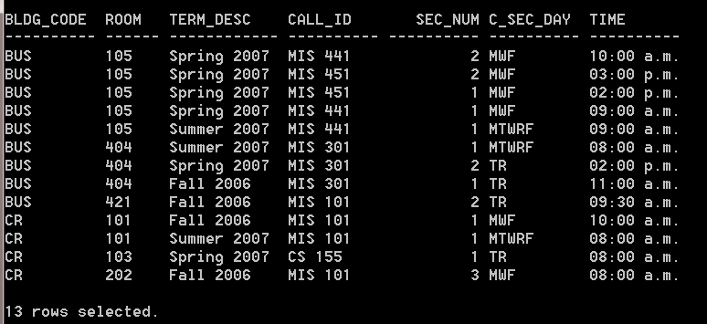
- List the building code and room of every record in the Location table, and also list the term description, call ID, section number, day and time of every course ever taught in that location. Format the TIME field so that values appear as times, not dates. Use the twelve-hour clock (a.m./p.m.) format. Order the records by the building code, then the room number.
(Hint: Inner joins)
(

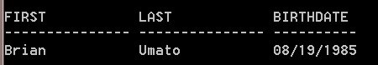
- Retrieve the S_FIRST, S_LAST, and S_DOB for all students whose classification (S_CLASS) is the same as the classification for Sarah Miller. Format the Student’s DOB using the format ‘MM/DD/YYYY’. Do not include Sarah Miller in the output. (Hint: subquery)
- Retrieve all of the fields from the ENROLLMENT table. For null entries, output two dashes (--), for all other grades, show two asterisks (**). In addition, also show the student’s first and last name. Order the output by last name, firstname as shown. (Hint: NVL2 function.)
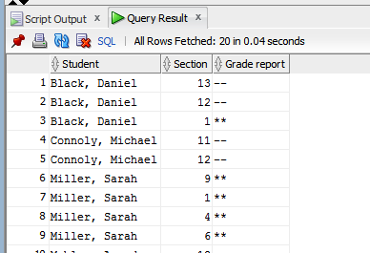 (Note: 20 records returned)
- Create a nested query that retrieves the student id and name of all students who have ever been enrolled in the same course section as the student who has student id = 2. Do not list student whose id is 2, and only list each name once, as shown:
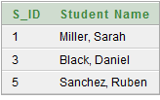

- How many employees earn more than the average salary? Display the column as “High Earners”, as shown below:

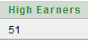

- Select one of the Chapter 5 Additional Problems.
- Select one of the Chapter 7 Additional Problems.

